Type-C DisplayPort 4K Video Adapter
Convert Your Existing Type-C Port On Your MacBookTM, WindowsTM and compatible Type-C devices to output video to DisplayPortTM DP displays, HDTV or projectors - up to 4K
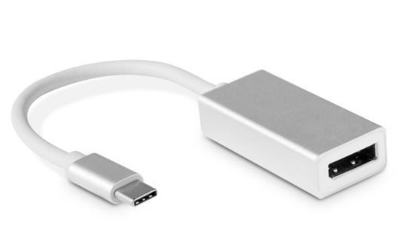

Descrption:

Convert Your Existing Type-C Port On Your MacBookTM, WindowsTM and compatible Type-C devices to output video to DisplayPortTM DP displays, HDTV or projectors - up to 4K

Utilize your existing Type-C port on your notebook, desktop or other compatible device and convert the port to a compatible DisplayPortTM DP signal output to your favorite DisplayPortTM monitor, HDTV or projector.

Supports surround sound audio when applicable and displays up to 4K resolutions on compatible displays. Ideal for all computers and compatible devices including MacBookTM, WindowsTM and other devices using the next-generation Type-C interface.

Features:
- USB 3.1 Type-C to HDMI / USB 3.0 / USB-C Multiport Adapter
- Charge your laptop / phone
- Macbook ,Chromebook with HDMI port
- Share movie on a larger TV/monitor/projector
- A great sidekick for your Laptop / Phone / Tablet with USB-C port
- HDMI Port: Output
- Support video resolution up to 4K UHD (3840x2160) 30Hz, and compatible with 1080P 60Hz, 720P.
- USB 3.0 Port:
- Transmission speed up to 5Gbps,and work with keyboard, mouse, flash drive or a USB cable for syncing and charging smartphones or other devices.
- USB-C Port:
- Charging laptop through Type-C female interface, 5W-60W automatically adaptive.
- How to Connect:
- Step 1: Connect USB Type-C connector of the Adapter to any USB Type-C HDMI mode supported devices.
- Step 2: Connect HDMI output of the cable to HDTV or HDMI enabled display using standard HDMI media cable.

Specifications
- Material: Aluminum alloy
- Cable Length: 10cm
- Color: Silver
- Input：type c
- Output：Display port
- Function: data transfer
- Resolution: 4K*2k(3840*2160 HD)
- Connector Type: USB C to DP, HDTV
- Certificate: CE FCC ROHS
- Operating Temperature:0℃ to +45℃
- Operating Humidity:10%0 to 85 % RH
- Storage Temperature : -10℃ to +55℃
- Storage Humidity: 5% to 90 % RH

Product Code:
Part number: C-TC-DIS
Barcode: 8400800036629
Size: 58mm x 18mm x 16mm
Wight (g): 100G

